**Business Question and Visualization Report**

| Date | 12 Oct 2025 |
| --- | --- |
| Team ID | SWUID20250216152 |
| Project Name | Predicting plant growth stages with environmental and management factors |
| Maximum Marks | 5 Marks |

Visualization development refers to the process of creating graphical representations of data to facilitate understanding, analysis, and decision-making. The goal is to transform complex datasets into visual formats that are easy to interpret, enabling users to gain insights and make informed decisions. Visualization development involves selecting appropriate visual elements, designing layouts, and using interactive features to enhance the user experience. This process is commonly associated with data visualization tools and platforms, and it plays a crucial role in business intelligence, analytics, and reporting

Business Questions and Corresponding Visualizations

The process involves defining specific business questions to guide the creation of meaningful and actionable visualizations in Power BI. Well-framed questions help in identifying key metrics, selecting relevant data, and building visualisation that provide insights.

### What is the average environmental condition across all growth observations?

**Visualization: KPI Cards**

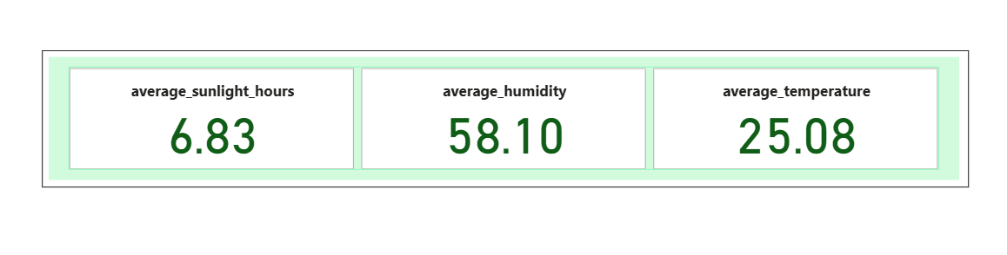Details:

Displays the average sunlight hours (6.83 hrs), average humidity (58.10%), and average temperature (25.08°C).

Insight: Indicates that plants generally grow in moderate conditions—ideal for most species.

### 2. How does water frequency impact plant growth across different soil types?

**Visualization: Matrix Table**

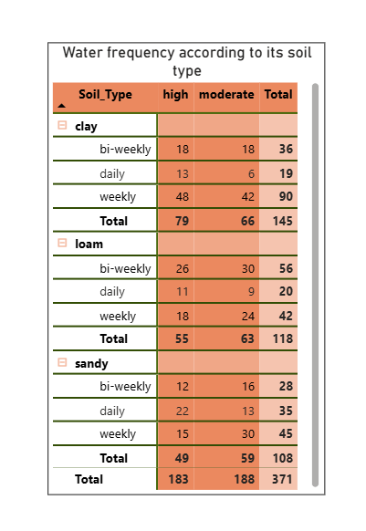

Details:  
 A detailed table showing Water Frequency by Soil Type with total growth milestones.  
 Insight: Daily watering leads to better growth performance, especially in loam soil.

### 3. Which soil type contributes most to plant growth milestones?

**Visualization: Decomposition Chart**

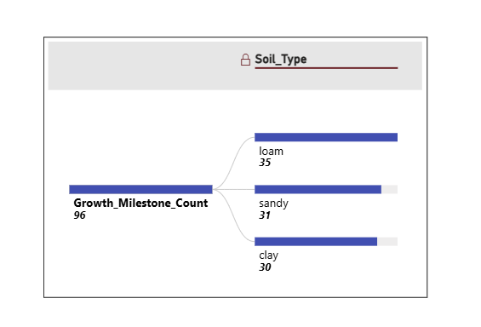

Details:

Compares growth milestone counts by soil type (Loam, Sandy, Clay).

Insight: Loam soil achieves the highest growth (35 milestones), followed by Sandy and Clay.

### 4. How does fertilizer type affect growth performance?

**Visualization: Donut Chart**

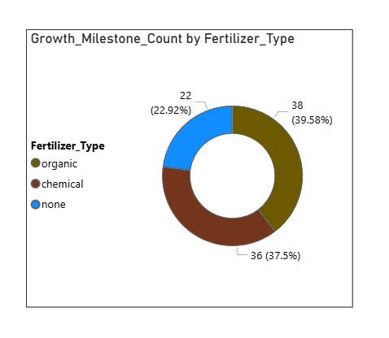

Details:  
 Displays percentage distribution of growth milestones for Organic, Chemical, and No Fertilizer.  
 Insight: Chemical fertilizers result in the highest growth (≈39.6%), but organic fertilizers promote sustainability.

### 5. What is the relationship between temperature range and plant growth?

**Visualization: Column Chart**

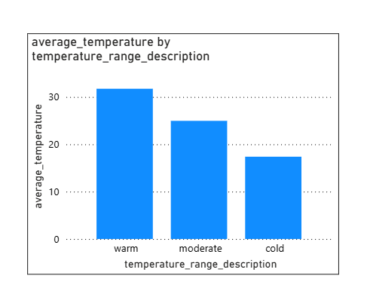

Details:  
 Compares average temperature values categorized as Warm, Moderate, and Cold.  
 Insight: Moderate temperature range (20–30°C) supports the best growth performance; cold conditions reduce growth by 9.7%.

### 6. How does humidity level affect growth milestones?

**Visualization: Line Chart**

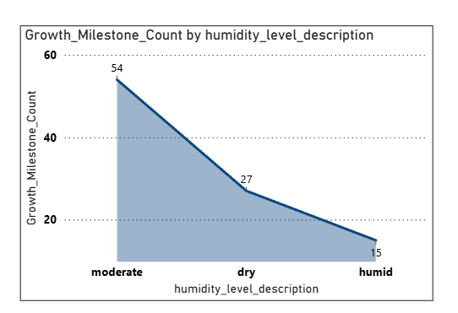

Details:  
 Displays growth milestone count by Humidity Level Description (Dry, Moderate, Humid).  
 Insight: Moderate humidity yields the highest growth milestones, confirming the importance of balanced moisture.

### 7. What is the contribution of watering frequency to total plant growth?

**Visualization: Tree Map**

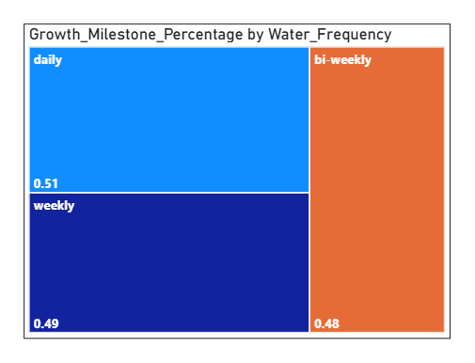

Details:  
 Shows relative growth contribution by Daily, Weekly, and Bi-Weekly watering frequencies.  
 Insight: Growth distribution is nearly even, but daily watering slightly leads, providing better soil consistency.

### 8. What is the overall sum of growth milestones achieved?

**Visualization: Gauge Chart**

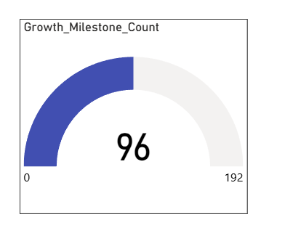

Details:  
 Displays the Sum of Growth Milestones = 96 out of 192 possible.  
 Insight: Represents 50% growth efficiency, suggesting potential for improvement through controlled humidity and temperature.